Unix Architecture
Here is a basic block diagram of a UNIX system:
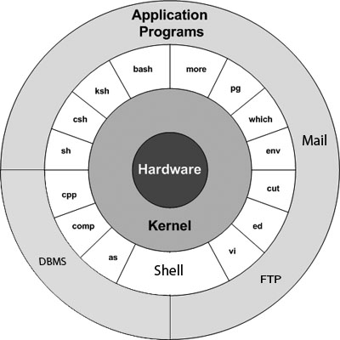
The main concept that unites all versions of UNIX is the following four basics:
- Kernel: The kernel is the heart of the operating system. It interacts with hardware and most of the tasks like memory management, task scheduling and file management.
- Shell: The shell is the utility that processes your requests. When you type in a command at your terminal, the shell interprets the command and calls the program that you want. The shell uses standard syntax for all commands. C Shell, Bourne Shell and Korn Shell are most famous shells which are available with most of the Unix variants.
- Commands and Utilities: There are various command and utilities which you would use in your day to day activities. cp, mv, cat and grep etc. are few examples of commands and utilities. There are over 250 standard commands plus numerous others provided through 3rd party software. All the commands come along with various optional options.

Files and Directories: All data in UNIX is organized into files. All files are organized into directories. These directories are organized into a tree-like structure called the filesystem.

Unix - What is Shells?
The shell provides you with an interface to the UNIX system. It gathers input from you and executes programs based on that input. When a program finishes executing, it displays that program's output.
A shell is an environment in which we can run our commands, programs, and shell scripts. There are different flavors of shells, just as there are different flavors of operating systems. Each flavor of shell has its own set of recognized commands and functions.

Shell Prompt:
The prompt, $, which is called command prompt, is issued by the shell. While the prompt is displayed, you can type a command.
The shell reads your input after you press Enter. It determines the command you want executed by looking at the first word of your input. A word is an unbroken set of characters. Spaces and tabs separate words.
Following is a simple example of date command which displays current date and time:
$date
Thu Jun 25 08:30:19 MST 2009

Shell Types:
In UNIX there are two major types of shells:
The Bourne shell. If you are using a Bourne-type shell, the default prompt is the $ character.
The C shell. If you are using a C-type shell, the default prompt is the % character.
There are again various subcategories for Bourne Shell which are listed as follows:
- Bourne shell ( sh)
- Korn shell ( ksh)
- Bourne Again shell ( bash)
- POSIX shell ( sh)
The different C-type shells follow:
- C shell ( csh)
- TENEX/TOPS C shell ( tcsh)
The original UNIX shell was written in the mid-1970s by Stephen R. Bourne while he was at AT&T Bell Labs in New Jersey.
The Bourne shell was the first shell to appear on UNIX systems, thus it is referred to as "the shell".
The Bourne shell is usually installed as /bin/sh on most versions of UNIX. For this reason, it is the shell of choice for writing scripts to use on several different versions of UNIX.

What is Substitution?
The shell performs substitution when it encounters an expression that contains one or more special characters.

Example
Following is the example, while printing value of the variable its substitued by its value. Same time "\n" is substituted by a new line −
#!/bin/sh

a=10
echo -e "Value of a is $a \n"
This would produce following result. Here -e option enables interpretation of backslash escapes.
Value of a is 10
Here is the result without -e option:
Value of a is 10\n
Here are following escape sequences which can be used in echo command −
Escape | Description
\\ | backslash
\a | alert (BEL)
\b | backspace
\c | suppress trailing newline
\f | form feed
\n | new line
\r | carriage return
\t | horizontal tab
\v | vertical tab

Command Substitution
Command substitution is the mechanism by which the shell performs a given set of commands and then substitutes their output in the place of the commands.

Syntax
The command substitution is performed when a command is given as:
`command`
When performing command substitution make sure that you are using the backquote, not the single quote character.

Example
Command substitution is generally used to assign the output of a command to a variable. Each of the following examples demonstrate command substitution −
#!/bin/sh

DATE=`date`
echo "Date is $DATE"

USERS=`who | wc -l`
echo "Logged in user are $USERS"
This will produce following result −
Date is Thu Jul 2 03:59:57 MST 2009
Logged in user are 1

